

Aditya Raj

BCIS309 – Work Integrated Learning Project, Software Development Pathway

Semester 1, 2021

SQL Test Automation for Ara Institute of Canterbury

Methodology Essay – Version 0.3

Table of Contents

Document Control 2

Part A – Literature Review 3

Agile Scrum Methodology 3

Scrum 4

Agile 4

Sprints 5

Pros and Cons 5

Software Development Process 6

Meeting and Planning 6

Designing and Development 6

Testing and Evaluation 6

Bibliography 7

# Document Control

|  |  |  |  |
| --- | --- | --- | --- |
| Date | Author | Version | Status of Document/Updates Made |
| 1/05/2021 | Aditya Raj | V0.1 | Document Creation |
| 19/05/2021 | Aditya Raj | V0.2 | Part A - First Draft Completed & Submitted for Marking |
| 21/05/2021 | Aditya Raj | V0.3 | Final Version Submitted for Marking |
|  |  |  |  |
|  |  |  |  |

# Part A – Literature Review

This section serves to discuss the literature review of the Agile Scrum methodology involved in this project including the phases of the Software Development process.

## Agile Scrum Methodology

The SQL Test Automation project at Ara Institute of Canterbury involves the use of the Agile Scrum methodology, an incremental development framework that allows for teams to collaborate while working on complex projects. This project applies the Agile Scrum methodology because of its many advantages that help satisfy the requirements of the company project unlike other methodologies such the Waterfall which because of its linear process does not allow for constant improvement and innovation for products in the ever-changing software market (Muslihat, 2018).

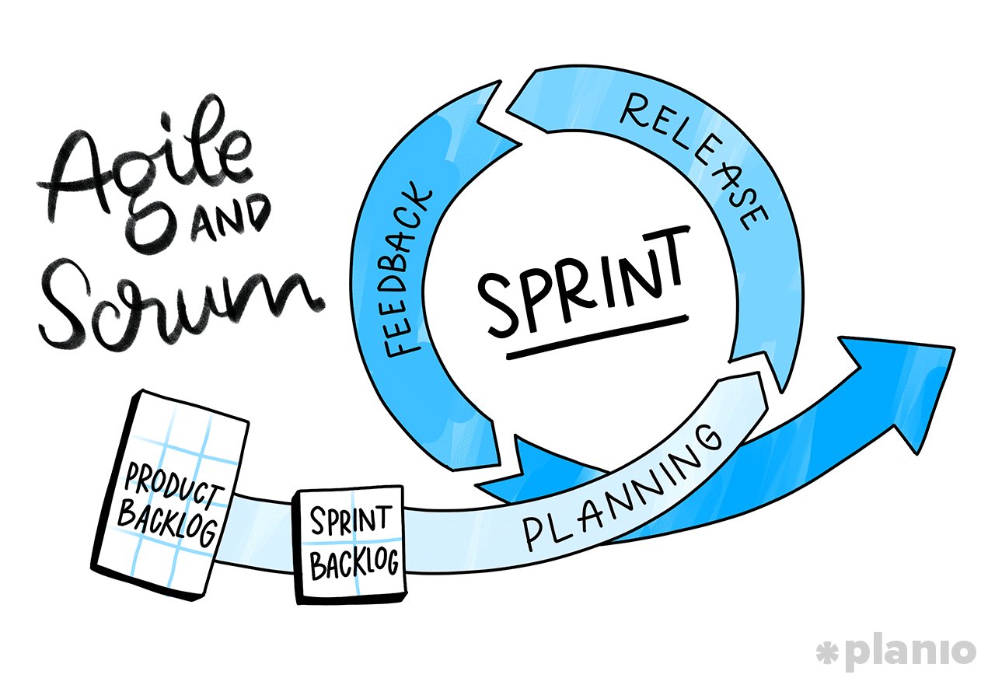

Figure 1 Agile and Scrum Diagram (MacKay, 2019)

With the Agile Scrum methodology, I was able to work in increments, by adding required features and making changes to the product in each sprint as per feedback from my industry supervisors. This methodology has been easy to understand and has allowed me to prioritise important features over features that will never be used. I have put into practice these steps of the process according to (Business News Daily Editor, 2020).

The following graph shows the process of the framework:

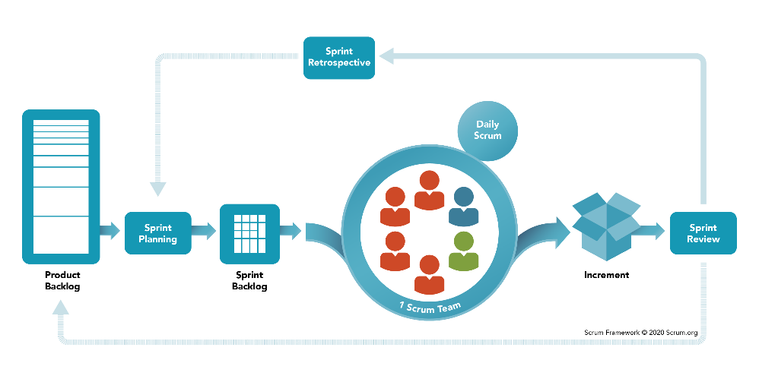

Figure 2 Scrum Framework (Scrum.org, 2020)

## Scrum

Scrum is a framework that allows for useful collaborations between teams that working on products with complexity. A scrum is made up of meetings, roles and tools that help teams to work together with a better arrangement and workload management (Business News Daily Editor, 2020). Scrum provides many benefits to complicated projects by requiring teams to complete a backlog, benefits to companies that value the results and benefit companies that accommodate their customers by developing products that meet customer needs and requirements (Business News Daily Editor, 2020).

## Agile

The Agile process allows the team to better manage their project by organising it into many stages, allowing for continuous teamwork with the stakeholders while steadily improving the product at every stage (Business News Daily Editor, 2020).

The 12 principles of agile that make projects superior are:

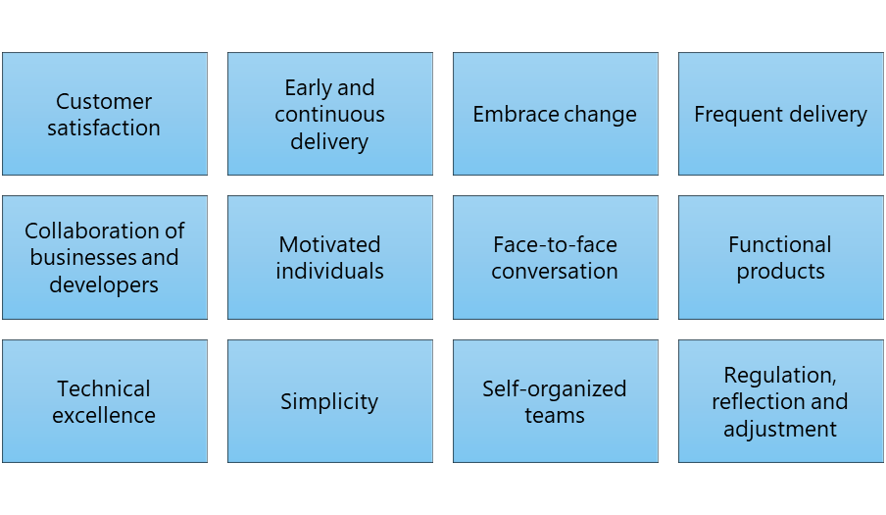

Figure 3 Principles of Agile (Business News Daily Editor, 2020)

## Sprints

Iterations are made up of two to four-week sprints in which each sprint has a goal for a deliverable product (Business News Daily Editor, 2020), however as a team consisting of one person, I have been doing sprints of one to two weeks. The purpose of Agile is to move fast while releasing frequently and responding to the needs of the industry client, therefore a complete list of requirements before starting work is not needed, instead, work continues in a single direction with the understanding that the progression will change through the project (MacKay, 2019).

## Pros and Cons

The following are the pros and cons of the Agile Scrum Methodology (Henricksen, 2019):

|  |  |
| --- | --- |
| Pros | Cons |
| Easy to explain and understand and light framework. | The product results are expected at the end of each sprint, teams need to work faster/harder. |
| Feedback allows changes to happen and better adapt the product to the company. | Scrum implementations can fail due to many company reasons. |
| Important features are prioritised over features that will never be used. | Excessive embracing change can lead to scope creep. |
| With scrum, the sprints are visible to all team members for them to work on. | Developers may not want to spend time on meetings. |

# Software Development Process

As this project involves the development of software, it uses the Software Development Process, a process made up of 6 phases, the following graph shows the phases in the cycle process:

Figure 4 Software Development Process (MacKay, 2019)

## Meeting and Planning

The first phase involves meeting your customer or stakeholder to analyse and plan for the project or sprint. The planning should include the connection of the project to the company’s goals, the resources and time required, the scheduling of tasks and cost estimation. Everyone involved in the project will need to be accounted for in the planning for the project to start efficiently. The planning will also involve the requirements, which includes the details of the product, the reasoning behind it and how it will come together according to the client (MacKay, 2019).

## Designing and Development

With the planning and requirements complete, the design and development can begin, this could include prototypes, user stories, wireframes, etc. The development of the software can then begin keeping in mind to avoid scope creep and building clean and efficient software according to the planning, requirements, and designs (MacKay, 2019).

## Testing and Evaluation

Testing can happen during the development phase while keeping track of bugs and errors. Once the features are complete and the product is ready, more in-depth testing is recommended before moving forward. Evaluation can happen and changes can then be issued for the next sprint. The process then restarts for the next sprint.

# Bibliography

Business News Daily Editor. (2020, February 25). *What Is Agile Scrum Methodology?* Retrieved April 3, 2021, from Business News Daily: https://www.businessnewsdaily.com/4987-what-is-agile-scrum-methodology.html

Henricksen, T. (2019, January 23). *Scrum pros and cons.* Retrieved April 4, 2021, from Medium: https://medium.com/@TomHenricksen/scrum-pros-and-cons-acf6b53b1ad6

MacKay, J. (2019, October 2). *Software Development Process: How to Pick The Process That’s Right For You.* Retrieved May 3, 2021, from Plan.io: https://plan.io/blog/software-development-process/

Muslihat, D. (2018, March 2). *Agile Methodology: An Overview.* Retrieved April 3, 2021, from Zenkit: https://zenkit.com/en/blog/agile-methodology-an-overview/

Scrum.org. (2020, November). *What is Scrum?* Retrieved May 4, 2021, from Scrum.org: https://www.scrum.org/resources/what-is-scrum